**PATRON:**

K.SUBATHRA M.E.,

PRINCIPAL & HOD/EEE

**CONVENER:**

Prof.I.THANGARAJU M.E.,Ph.D

AP/EEE

**STUDENT MEMBERS:**

Mr.R.Naveen Kumar

Final year EEE

Mr. Durai Raj

III year EEE

**ADDRESS FOR COMMUNICATION:**

The general secretary,

ELECTRYONZ’13,

Department of EEE,

Government College of Engineering,Bargur-635104.

Mobile: 8056485923

E-mail id: electryonz2k13@gmail.com

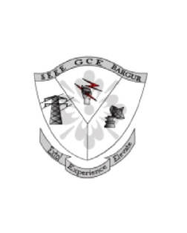

To

The **HOD/EEE**,

Dear Sir/ Madam,

Sub: Inviting for **ELECTRYONZ’13** a NATIONAL LEVEL TECHNICAL SYMPOSIUM-reg.

We are glad to invite you for the national level technical symposium **“ELECTRYONZ’13”** organized by Society of Electrical and Electronics Engineers on **24th &25th of September 2013** and a workshop for **PLC AND AUTOMATION** on **21st September 2013** in our college premises.

We organize this function every year, which comprise of events like Workshop, Paper Presentation, Project expo, Technical marketing, Circuit Debugging, Circuit Designing to expose the electrifying skills of the students.

Herewith, we have enclosed the poster of **ELECTRYONZ’13** and we request you to display it on your department notice board for the benefit of students to take active participation in all events which would be the real challenge for their creative mind and innovative thoughts.

Thanking you,

(Note: students who wants to participate in workshop,

Please enclose your details to mail: [electryonz2k13@gmail.com](mailto:electryonz2k13@gmail.com) and find us on facebook)

Enclosure: Poster

(PROF &HOD/EEE)